# Post-processing

<https://dafoam.github.io/mydoc_get_started_post_processing.html>

Check opt_IPOPT.txt for optimization progress and use Paraview to visualize flow fields.

内容目录：

[Check optimization output file opt_IPOPT.txt](https://dafoam.github.io/mydoc_get_started_post_processing.html#check-optimization-output-file-opt_ipopttxt)

[Visualize the flow fields using Paraview](https://dafoam.github.io/mydoc_get_started_post_processing.html#visualize-the-flow-fields-using-paraview)

*.gif

Fig. 1. Pressure and shape evaluation during the optimization process

## Check optimization output file opt_IPOPT.txt

Once optimization is done, first check “opt_IPOPT.txt” in tutorials-main/NACA0012_Airfoil/incompressible. “opt_IPOPT.txt” contains the variation of functions with respect to the optimization iteration:

iter objective inf_pr inf_du lg(mu) ||d|| lg(rg) alpha_du alpha_pr ls

0 2.0820236e-02 2.26e-08 8.55e-02 0.0 0.00e+00 - 0.00e+00 0.00e+00 0

1 2.0521266e-02 3.20e-04 6.86e-02 -5.9 9.91e-03 - 9.71e-01 1.00e+00h 1

2 1.9623489e-02 2.54e-03 2.73e-01 -3.5 2.17e-02 - 9.75e-01 1.00e+00h 1

3 1.9314850e-02 8.73e-04 6.61e-03 -4.3 2.10e-02 - 1.00e+00 1.00e+00h 1

4 1.9241231e-02 1.72e-04 3.71e-03 -5.8 2.80e-02 - 1.00e+00 1.00e+00h 1

5 1.9231794e-02 6.45e-06 8.07e-04 -6.2 9.33e-03 - 1.00e+00 9.97e-01h 1

6 1.9170888e-02 7.57e-05 3.15e-03 -7.2 8.75e-02 - 1.00e+00 1.00e+00h 1

7 1.9133030e-02 1.68e-04 1.09e-02 -6.9 1.07e+00 - 1.00e+00 2.23e-01h 3

8 1.8913613e-02 2.22e-04 1.26e-02 -7.5 8.09e-01 - 1.00e+00 5.00e-01h 2

9 1.8691236e-02 2.76e-03 1.64e-02 -6.8 6.77e+00 - 1.00e+00 1.66e-01h 2

iter objective inf_pr inf_du lg(mu) ||d|| lg(rg) alpha_du alpha_pr ls

10 1.9355900e-02 2.63e-03 3.41e-02 -6.5 1.07e+00 - 1.00e+00 8.96e-01H 1

11 1.9355900e-02 2.63e-03 1.21e-01 -6.6 8.43e-01 - 1.51e-02 1.00e+00h 1

12 1.7524672e-02 6.56e-02 2.01e-01 -6.6 2.76e+02 - 5.47e-03 1.33e-03h 1

13 1.7855004e-02 2.39e-03 8.60e-03 -6.1 4.63e-01 - 1.00e+00 1.00e+00h 1

14 1.7799861e-02 9.25e-04 3.58e-03 -7.0 2.62e-01 - 1.00e+00 1.00e+00h 1

15 1.7800851e-02 1.32e-04 2.68e-03 -8.6 2.46e-01 - 1.00e+00 1.00e+00h 1

16 1.7802465e-02 8.81e-06 6.38e-04 -7.5 2.70e-02 - 1.00e+00 1.00e+00h 1

17 1.7802033e-02 2.50e-06 6.62e-05 -9.4 1.01e-02 - 1.00e+00 1.00e+00h 1

18 1.7802058e-02 5.87e-09 2.90e-06 -11.0 1.17e-03 - 1.00e+00 1.00e+00h 1

The objective (CD) is 0.02082 for the baseline design and drops to 0.01780 for the 18th optimization iteration with a drag reduction of **14.5%**. The optimality (inf_du) and feasibility (inf_pr) decrease to be less than 1e-5.

## Visualize the flow fields using Paraview

Next, we can use [Paraview](https://www.paraview.org/) to visualize the flow fields. Download the Paraview binaries [from here](https://www.paraview.org/download). They are ready to use for Windows, Linux, and MacOS. Once installed, open the Paraview app and click “File->Open…” from the top menu. In the pop-up window, navigate to tutorials-main/NACA0012_Airfoil/incompressible, select the paraview.foam file, and click “OK”.

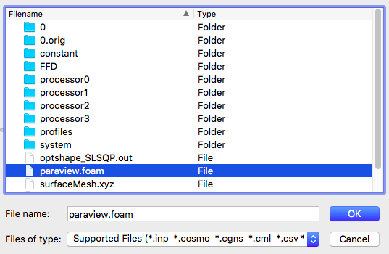

Fig. 2. Open the paraview.foam file

Then at the left panel, select “**Decomposed Case**” for “Case Type”.

**Note:** The **Decomposed Case** type tells Paraview to load data from processor* folders since we ran this case in parallel using 4 CPU cores. If one runs a serial run with one CPU core, select **Reconstructed Case** for **Case Type** instead.

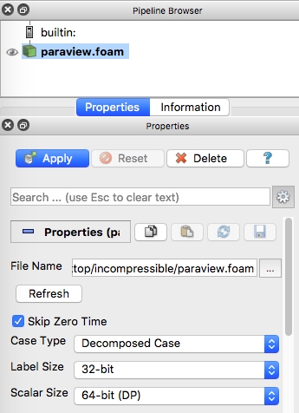

Fig. 3. Select Case Type

Next, scroll down at the left panel and check “Camera Parallel Projection”.

**Note:** The **Camera Parallel Projection** option is preferable for zoom-in visualization.

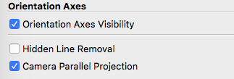

Fig. 4. Check Camera Parallel Projection

Now, click “Apply” at the left panel to load the flow fields. By default, the pressure field (p) will be load, but you can choose other flow variables to load at the top panel. Also, the “Surface” representation will be used by default, you can change it to “Surface With Edges” to visualize the mesh.

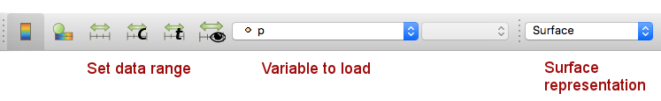

Fig. 5. Change variable to load and surface representation

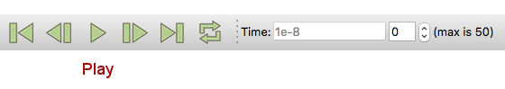

Fig. 6. Hit play to visualize a movie of optimization process

Finally, you can hit the play button at the top panel to play a movie of evolution of pressure field and shape during the optimization (see the movie at the beginning of this page).

Refer to the [Paraview User Guide](https://www.paraview.org/paraview-guide) for more advanced usage.

In the next [page](https://dafoam.github.io/mydoc_get_started_runscript.html), we will elaborate on optimization run scripts and configuration files.